MKT 6323 Database Marketing

Assignment 1

Chih-Kai Wang
Kuo-Chi Lin
Te-Hsuan Lung
Wei-Min Huang
Yu-Min Wang

Sep. 28, 2017

Part I
1, 2, 3 : run SAS.

Part II
4.
(a.) What is the interpretation of the intercept, the coefficient of lot size, beds and other variables?
Intercept : -49.58856 shows that when we take out all the variables of the regression, the price of the house is -$49,588.56
LotSize: 4.05389 means if the LotSize increases by 1 sq. feet, the selling price will increase by $4.05389
Bed : 0.32847 means if the # of bedroom increases by 1, the selling price will increase by $328.47
Other: 11.78519 means if the # of Other room increases by 1, the selling price will increase by $11,785

(b.) What does the sign of the coefficient tell you?
The sign of the coefficient tells me whether there will be an increase or decrease of selling price (by unit of $1000) for each unit increase of the corresponding variable. A negative sign shows that there will be a decrease of price for each unit of increase in the variable. A positive sign shows that there will be an increase of price for each unit of increase in the variable.
(c.) Based on the relationship you have estimated, how do you determine if a variable such as lot size has a significant (statistically significant) impact on sale price?
The p-value of lot size is <.0001 which is smaller than 0.05 so that lot size has a significant impact on the sale price. Here we set significance level α = 0.05.
(d.) Are the signs, magnitude and significance of the coefficients consistent with intuition – why/why not?
Intercept : when we take out all the variables the house price will be negative. The intuition is there is no negative price.
Bed: if the # of Bedroom increases by 1, the selling price ONLY increases by $328? That is too small especially if the extra Bathroom will increase price by $27,797.
Fence: a fenced house will be sold at a price lower than an unfenced house by $24,685. The intuition is a fenced house usually can be sold at a higher price.
Age : 1.409 means if the age of house increases by 1 the selling price will increase by $1409. Our intuition is the older house has the lower price.

(e.) Does the model fit the data well – what criteria do you use to assess goodness of fit?
Yes, it fits the data well. The R-Square of the model is 0.8705, which shows a high fit in the data.

5. Based on the results of the estimation in #2, answer the following questions:
(a) What do the correlations between variables reveal?
In factor analysis, variables that are highly correlated can be categorized into the same Factor.
Based on this Exhibit, we can realize some relationships. First of all, in the group “Bed”, “Bath”, “Other”, “Stories” and “Cars”, any two of them are highly correlated. It makes sense. However, “Lotsize” is not correlated with “Bed”, “Bath”, “Other”, “Stories” and “Cars.” Besides, the correlation between “Section” and “Age” are highly negative correlated. This means the houses in section 9 must be younger than the houses in section 4.
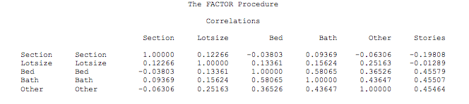
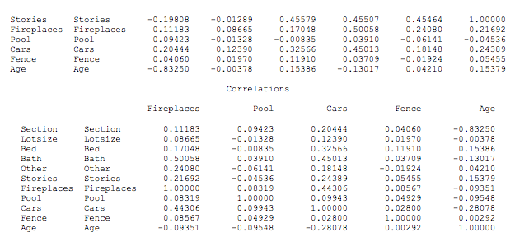

(b)Assign labels to the factors and provide a justification for these labels - justification should be based on results in #2.
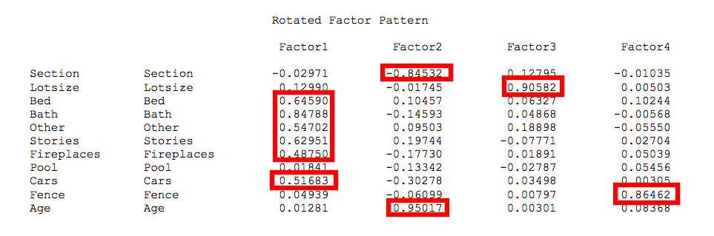

Factor | Factor1 | Factor2 | Factor 3 | Factor4
Name | Facility | Development | Space | Fence
Variable(s) | Bed | Section | Lotsize | Fence
Variable(s) | Bath | Age
Variable(s) | Other
Variable(s) | Stories
Variable(s) | Fireplace
Variable(s) | Cars
Reason | All variables in Factor 1 are related to facility of house. | Both variables are related to development of house. Ex: section 4 might be better developed than section 9 because this section is older, so the house in section 4 is older than section 9. | Only this variable “Lotsize” is in this Factor3. | Only this variable “Fence” is in this Factor4.

(c) Based on the results how many factors would you consider in summarizing the information in the explanatory variables – why? What percentage of the total information in the explanatory variables is summarized in the factors that you have decided to retain?
Choose factors 1,2,3 and 4 in summarizing the information in the explanatory variables. The eigenvalue of 1,2,3,4 is as follows: 2.939, 2.085, 1.105, 1.006. Factors with eigenvalue of >1 are considered to be doing a good job. 64.89% of the total information in the explanatory variables is summarized in the 4 factors that are retained.
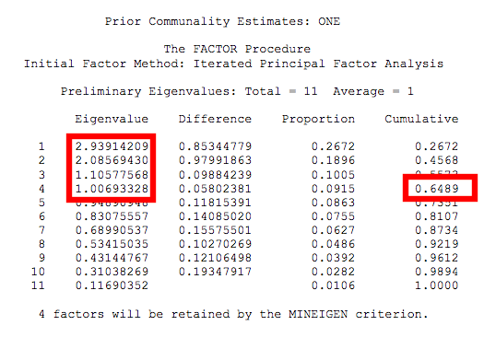

6. Based on the results of the estimation in #3, answer the following questions:
(a) How do you interpret the intercept, and the coefficient of the factors?
The coefficient of the intercept is 110.69889, it indicates the estimated price = $110,698.89 when we take out all the factor variables of the regression.
Factor1 (facility) : coefficient is 48.49765, it states if Factor1 increases by 1, then the selling price will increase by $48,497.65
Factor2 (development) : coefficient is 33.47961, it indicates if Factor2 increases by 1, then the selling price will increase by $33,479.61
Factor3 (space) : coefficient is 57.20019, it indicates if Factor3 increases by 1, then the selling price will increase by $57,200.19
Factor4 (fence) : coefficient is -8.30845, it indicates if Factor4 increases by 1, then the selling price will decrease by $8,308.45
(b) Are the signs and the magnitude of the coefficients of the factors consistent with intuition and the labels you have assigned in 6c – why/why not?
The results are more reasonable. Intercept coefficient becomes positive now. Factor1-Factor 3 are consistent with intuition. Factor4(fence) coefficient is still negative. The intuition is a fenced house usually can be sold at a higher price.
(c)Does this model fit the data better than the model in step 1 - why/why not?
We do not agree that this model fit the data better than the model in step 1, because it’s R-squared is 0.8412. It is slightly lower than the previous model whose R-squared is 0.8705. However all factors in this new model are significant.

7. Suppose a seller wanted to spend $10,000 on home improvement before selling the house. Assume that the lot size cannot be changed.
(a.) If $10,000 were barely enough to make one update – add a bedroom, add a pool, etc., where would you recommend that the money be spent? Why?

We would recommend to spend on increasing the number of baths. Among all the significant variables, bath has the highest coefficient (27.7972) which means bath has the highest increased price among all variables.
(b.) If $10,000 were enough to make two updates – add a bedroom and a pool, etc., which two updates would you recommend and why?

We would recommend to spend on increasing the number of bath and the number of stories because these are two variables with the highest coefficients among all variables, and they are significant. So the increased price will be the highest.

